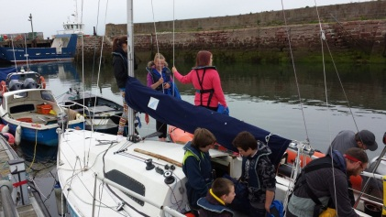
Sailing
Tuesday nights 5.15pm – 8.30pm (Rota Each Week)

Free of Charge
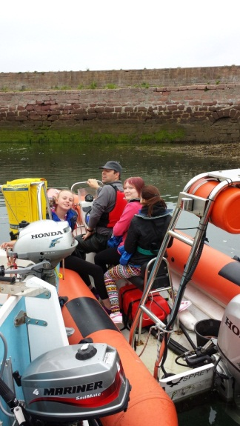
You will learn how
- To sail the boat from basics,
- Some navigation,
- Basic First Aid,
- VHF radio operation
- Using the Rib (the safety boat.)
- port and starboard winch operator

All the safety equipment is provided

Each week you will get the opportunity to try something different on the boat.
At any one time there will be 3 young people on the boat with a fully qualified instructor. Another 3 young people will be on the RIB with a fully qualified instructor

Each week there will be rote of who is going out.
Please See Wanda or Fraser If you are interested
Wanda 07515717011
Fraser 07541259484

